Struts 2 ValueStack and OGNL
ValueStack is the storage area where the application data is stored by Struts 2 for processing a client request.
Object-Graph Navigation Language (OGNL) is a powerful Expression Language that is used to manipulate data stored on the ValueStack. Both interceptors and result pages can access data stored on ValueStack using OGNL.

The Value Stack
For each action invocation, an object called the Value Stack is created prior to action method execution. The Value Stack is used to store the action and other objects. The Value Stack is accessed during processing (by interceptors) and by the view to display the action and other information. In order for a JSP to access the Value Stack, the Struts framework stores it as a request attribute named struts.valueStack.
There are two logical units inside the Value Stack, the Object Stack and the Context Map.

Struts pushes the action and related objects to the Object Stack and pushes various maps to the Context Map.
The Value Stack

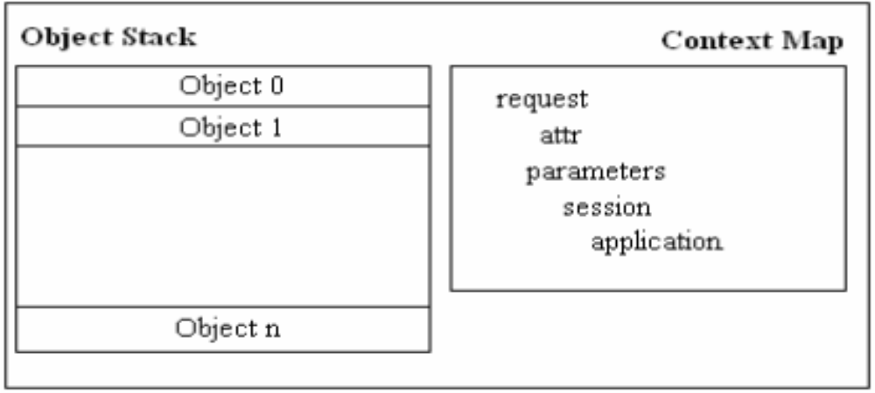

Note :

The term Value Stack is often used to refer to the Object Stack in the Value Stack.
The following are the maps that are pushed to the Context Map.
• parameters. A Map that contains the request parameters for the current request.
• request. A Map containing all the request attributes for the current request.
• session. A Map containing the session attributes for the current user.
• application. A Map containing the ServletContext attributes for the current application.
• attr. A Map that searches for attributes in this order: request, session, and application.

You can use OGNL to access objects in the Object Stack and the Context Map. To tell the OGNL engine where to search, prefix your OGNL expression with a # if you intend to access the Context Map. Without a #, search will be conducted against the Object Stack.

